**Version Control and Virtual Environment Essentials**

As preparation for this, download and install the following software and install it to your local computers

Go on the link to download of **Git** Software, then install it.

<https://git-scm.com/downloads>

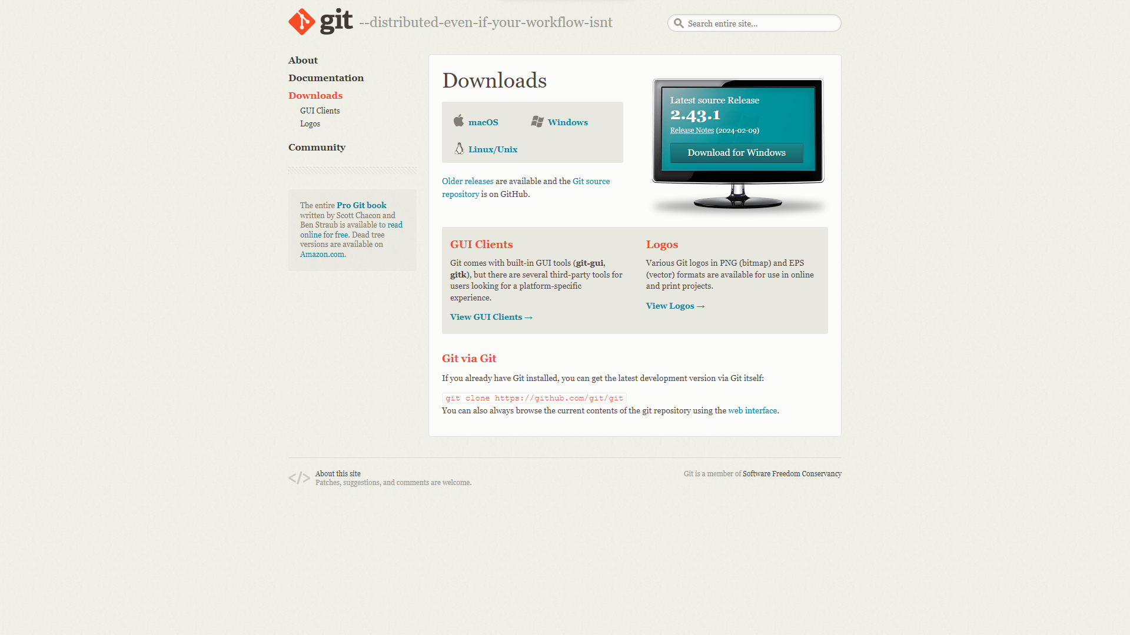

Go on the link to download of **Visual Studio Code** (*text editor*), then install it.

<https://code.visualstudio.com/>

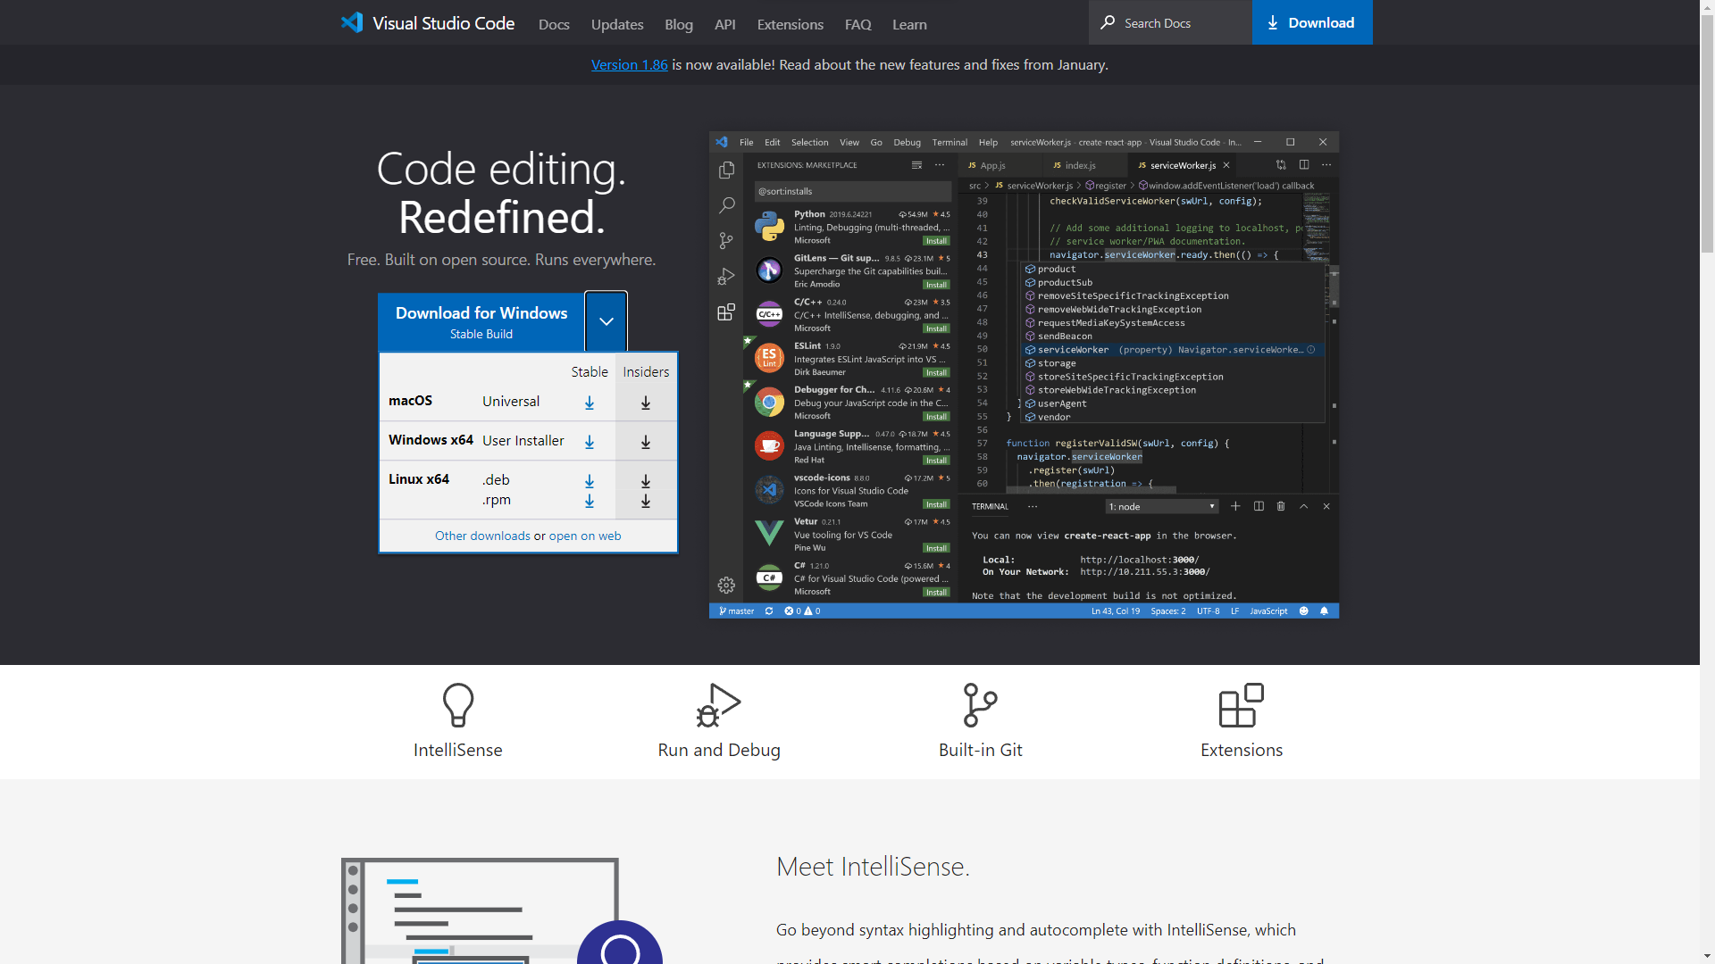

Go on the link below and download **Python**, then install it.

<https://www.python.org/downloads/>

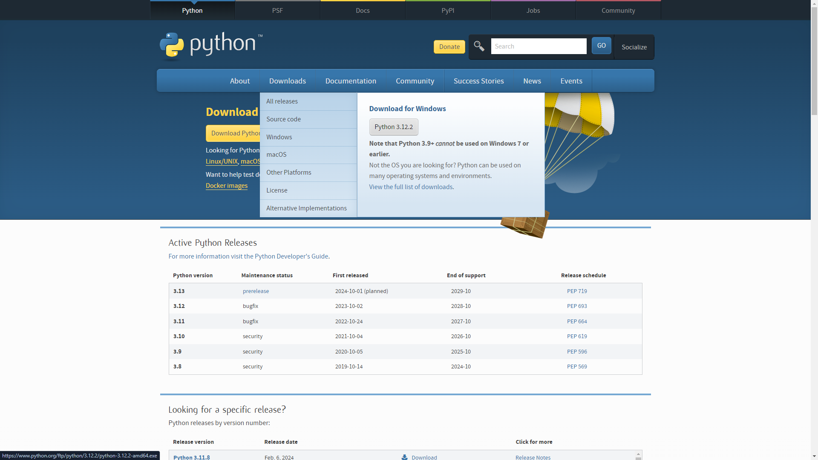

Go on the link below and download **GitHub** **Desktop**, then install it.

<https://desktop.github.com/>

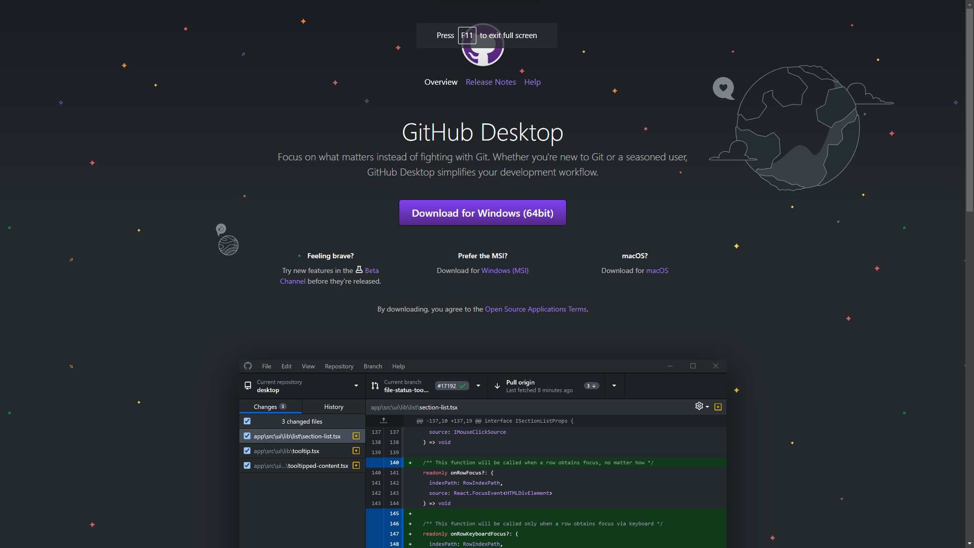

Create an **Github Account** by signing-up.

<https://github.com/signup>

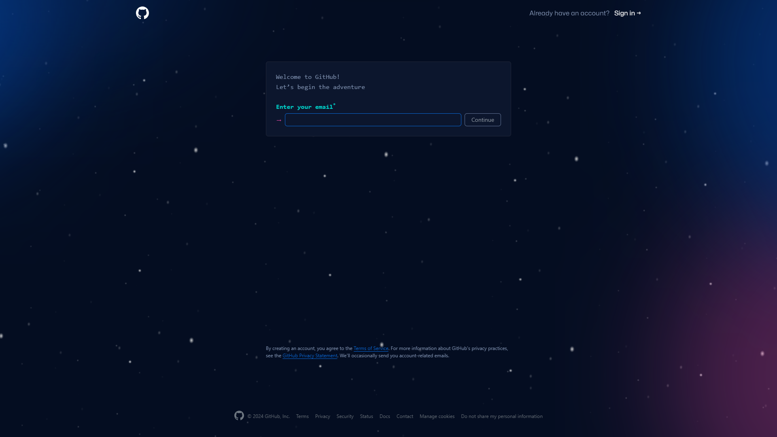

* Once the account was created, Go to the dashboard and click “New” to create new repository.

<https://github.com/dashboard>

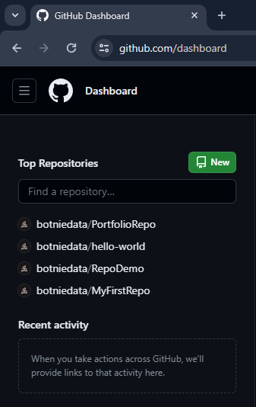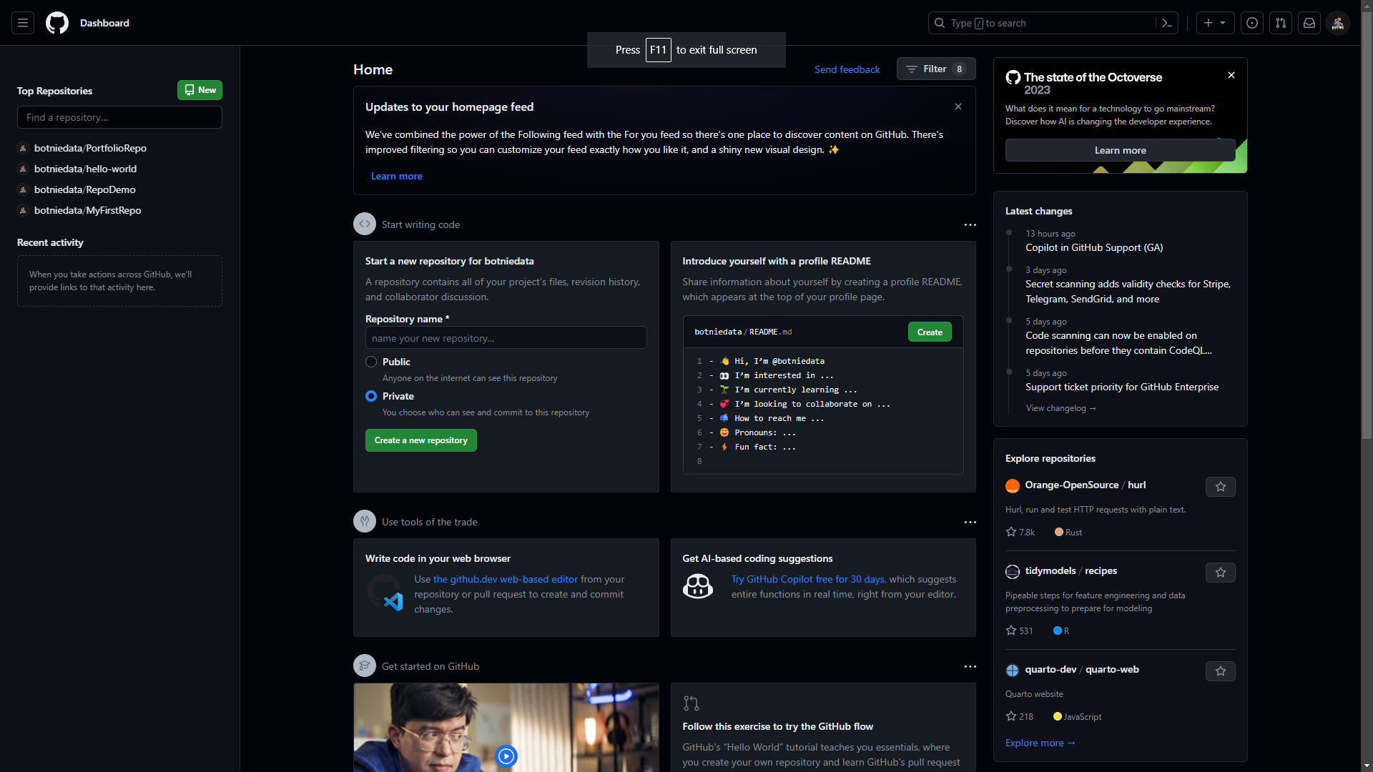

1. Create your Repository’s name
2. Set your repository into public
3. Uncheck add a README.md, “None” for .gitignore and license
4. Click “Create Repository” to create your repository

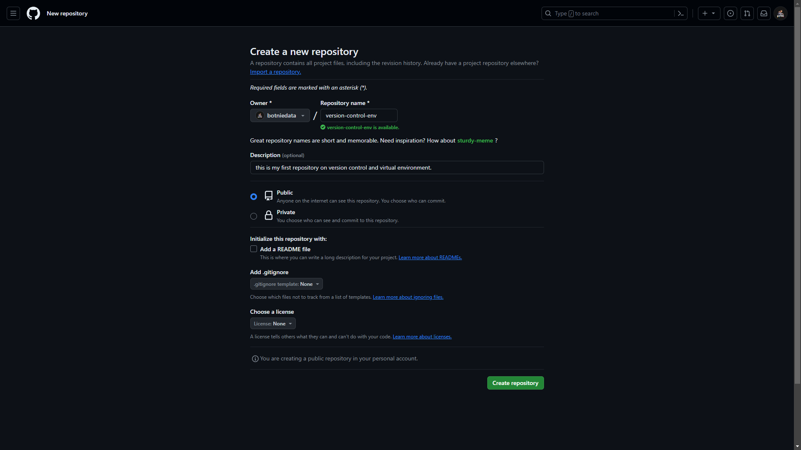

2

4

3

1

Note: *On VS Code Editor we will create manually the README.md and .gitignore file.*

* Open Command Prompt to start creating our README.md and .gitignore files.

Make a directory by tying “**mkdir** **<directory_name>”**, hit Enter to create

Code:

**mkdir version_control_env**

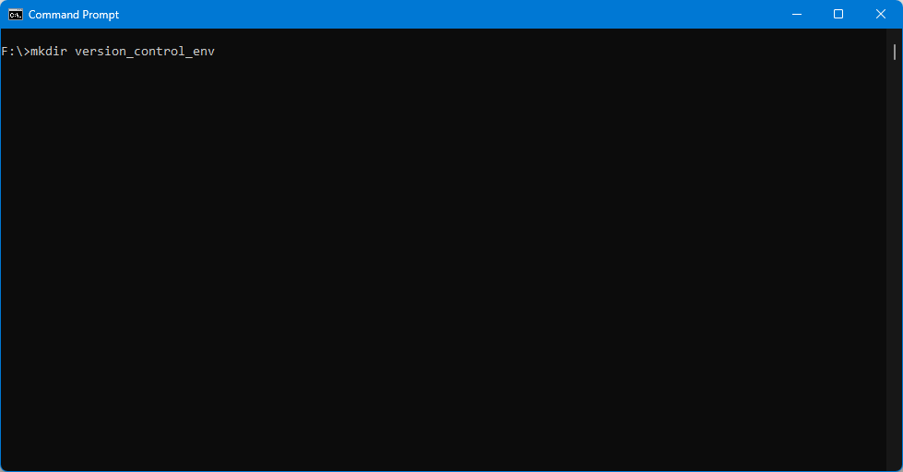

Change directory to the created folder

Code:

**cd version_control_env**

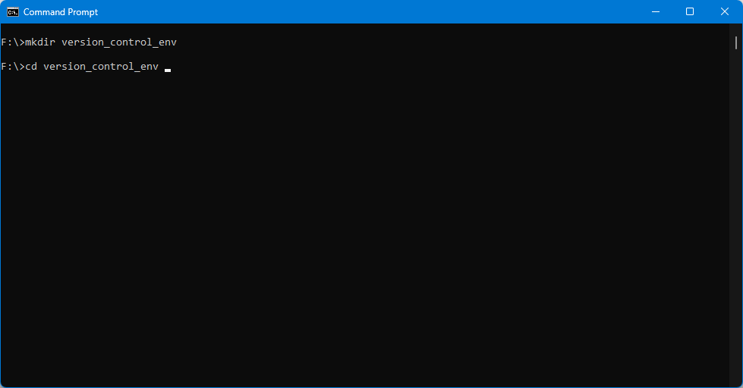

Create and Initialize our first local Git Repo

Code:

**git init .**

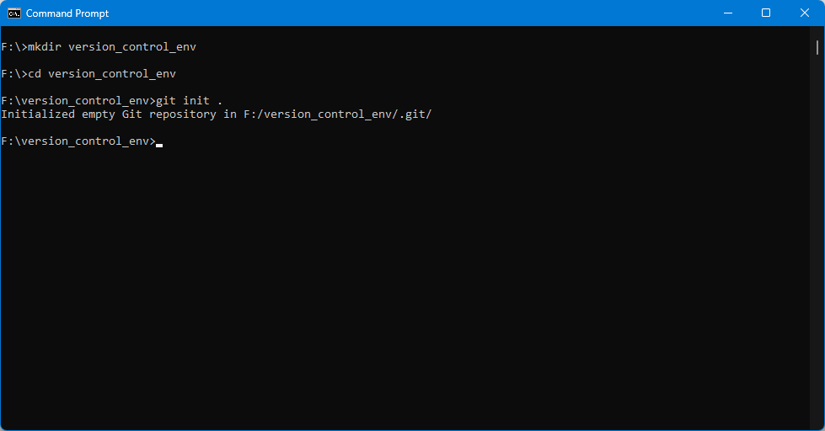

Create new file name as “README.md”

Code:

**echo “***<some-messages>***” > README.md**  
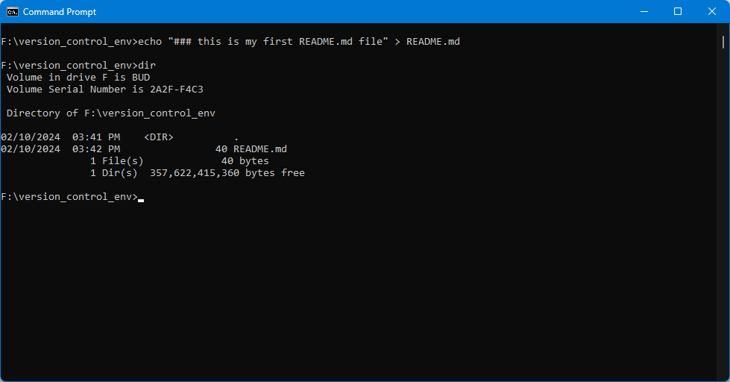

Create .gitignore file to avoid push all files from the directory **“env/”**

Code:

**echo “env/” > .gitignore env/ means environment**

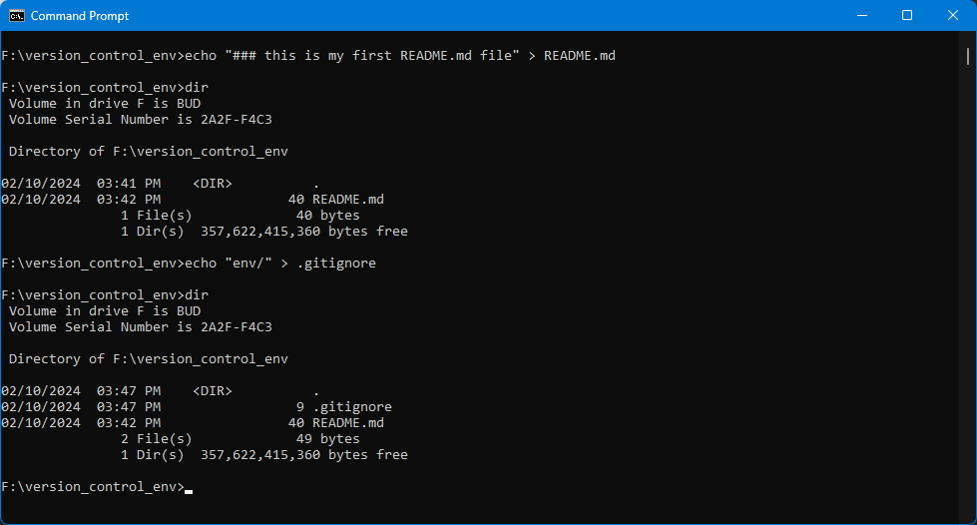

Put unstagged file and commit

Code:

**git add .**  - staged all files or you can use **git add <file>**

**git commit –m “<some-comment>”** - writing status on the activities done

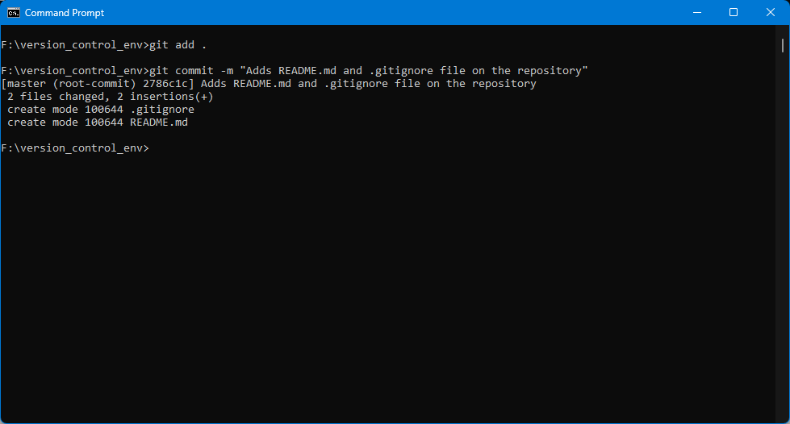

Creating Modular Python **Env**ironment *(folder)* on the local repository

Code:

**python –m venv env**

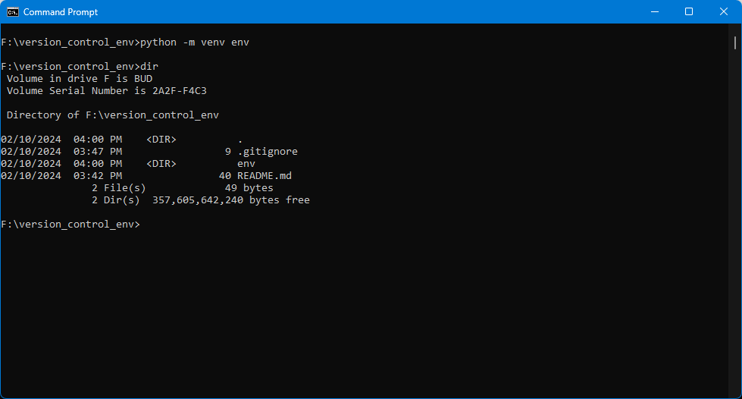

Open the Visual Studio Code Editor

Code:

**code .**

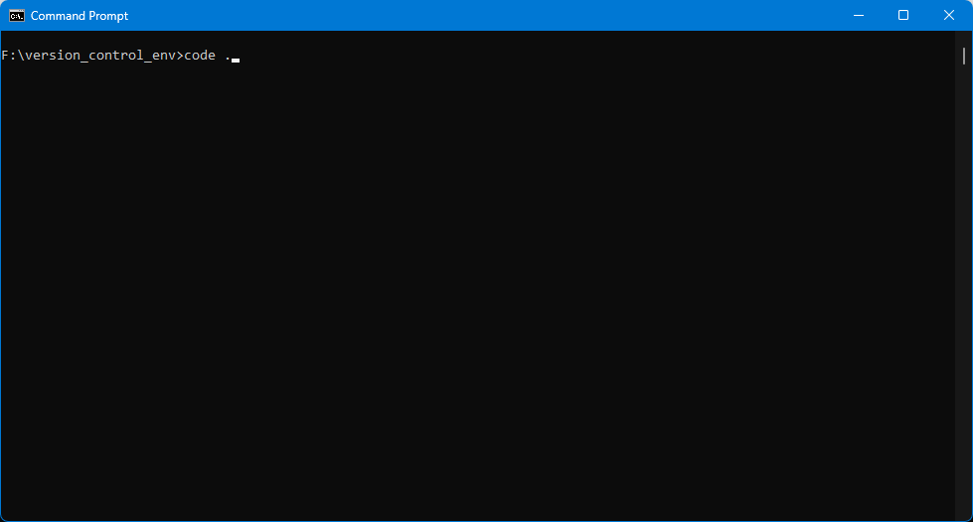

Check all the files created on Explorer Pane, make sure the **env** was gray

* **README.md**
* **.gitignore**
* **env** *(folder)*

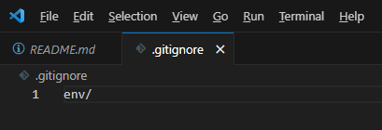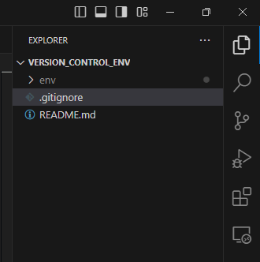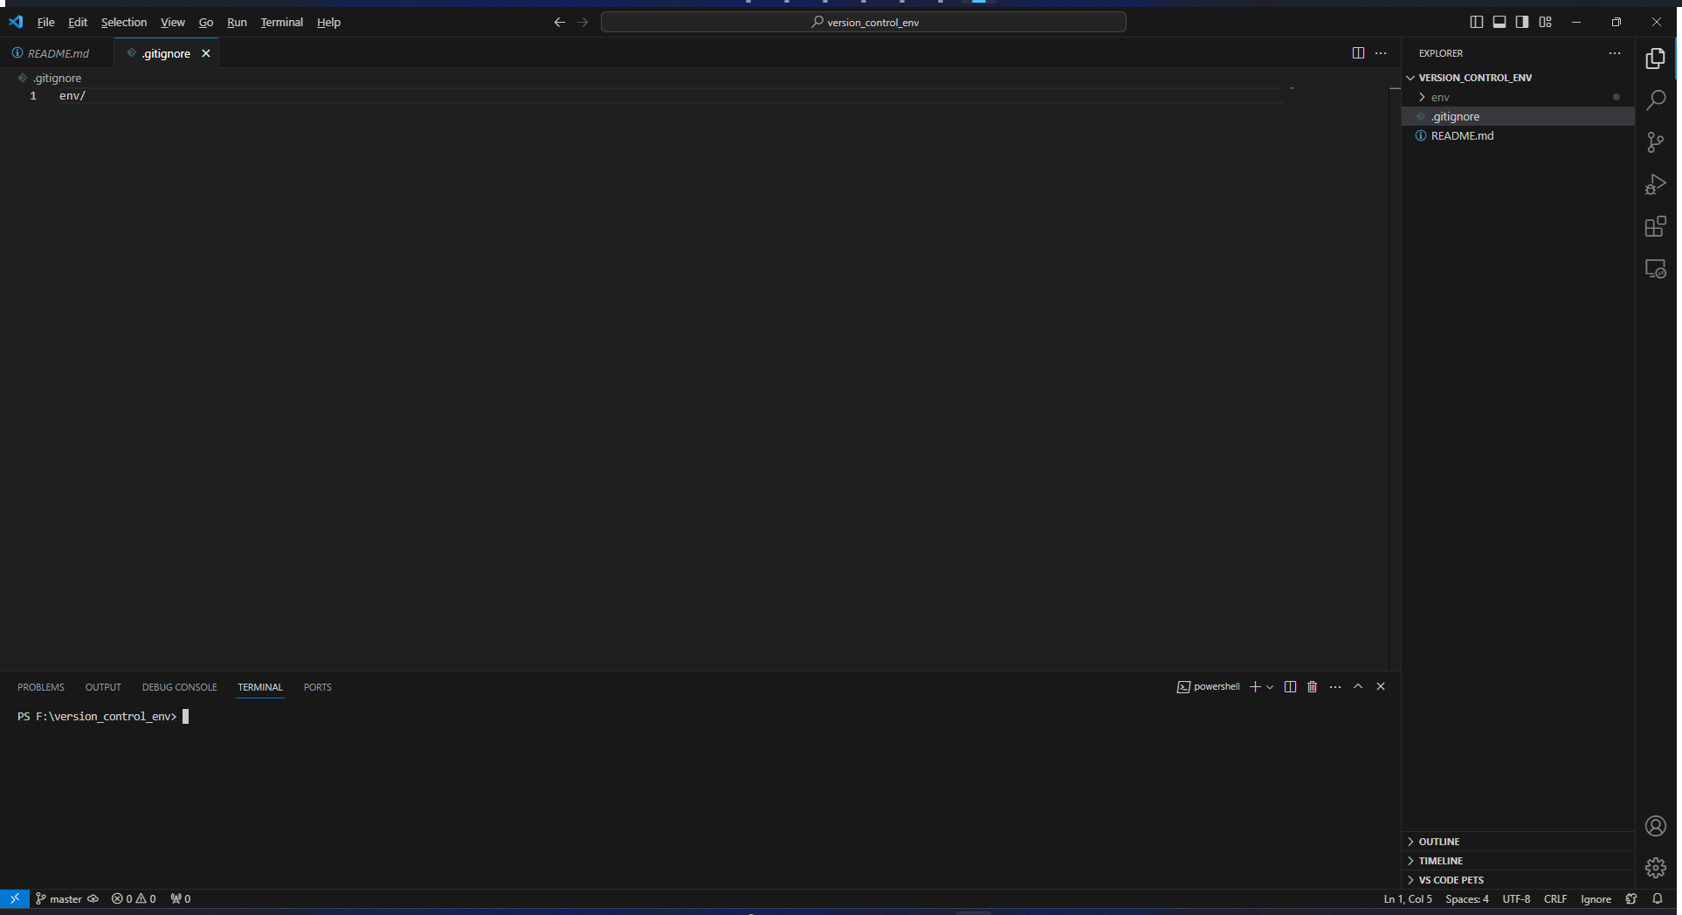

Note: if the **env** wasn’t gray out it means the .gitignore file doesn’t take effect so, remove the **.gitignore** and recreate again via VS Code Editor.

Activate the environment, if the **(env)** display on the start next in line it means environment is activated.

Code:

**env\Scripts\activate.bat**

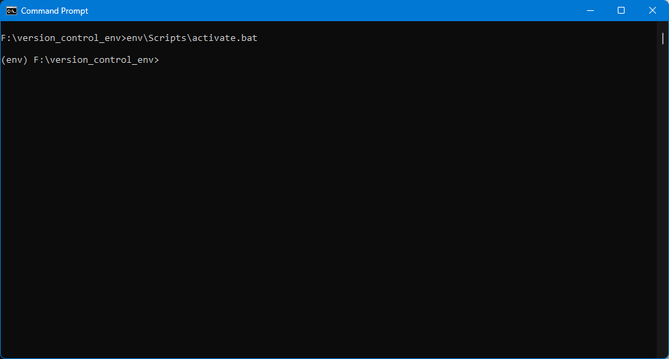

Create now text file to download all the packages requirements

Packages:

* **sqlalchemy**
* **pandas**
* **psycopg2**

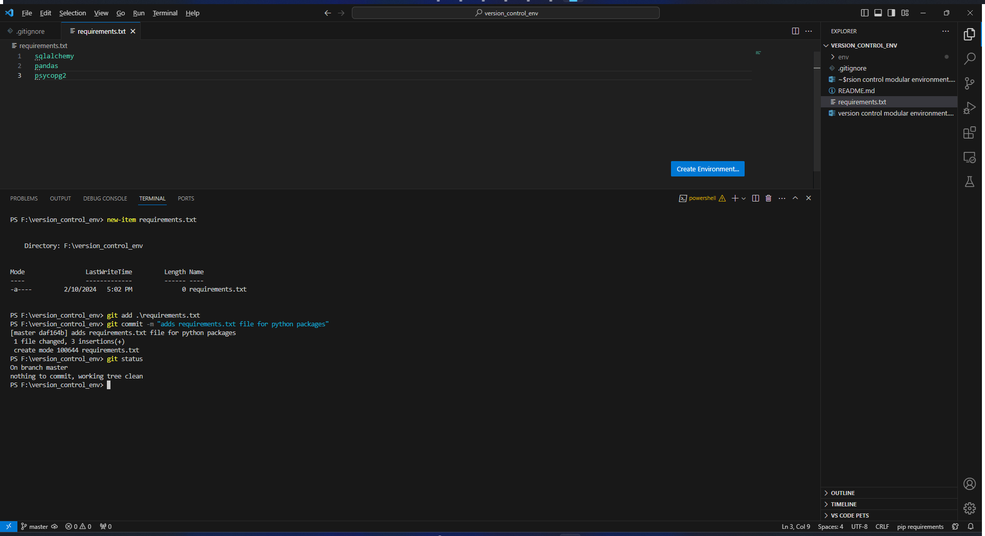

Download now the requirements on requirements.txt using python. Once the download is done **deactivate** the environment.

Code:

**pip install -r requirements.txt**

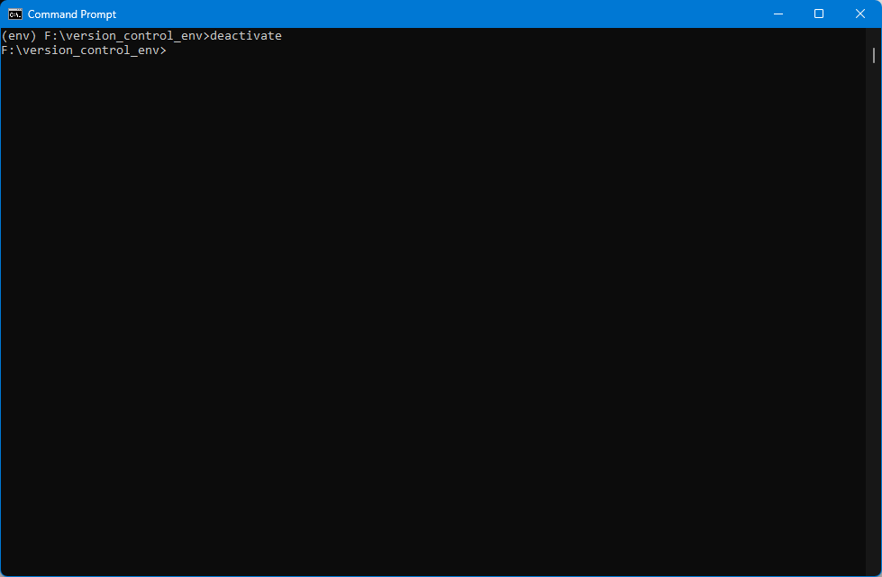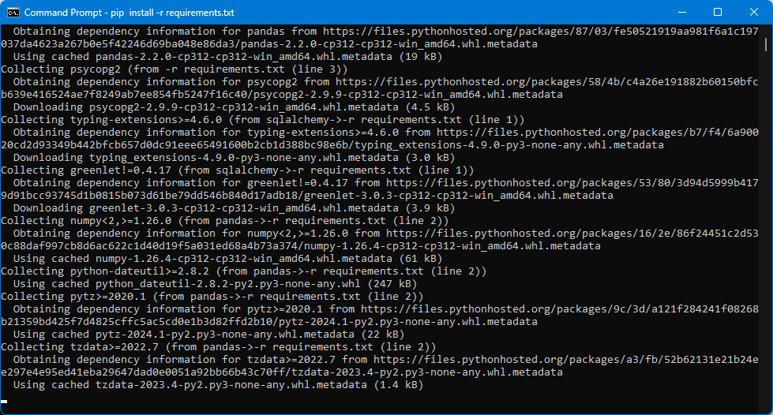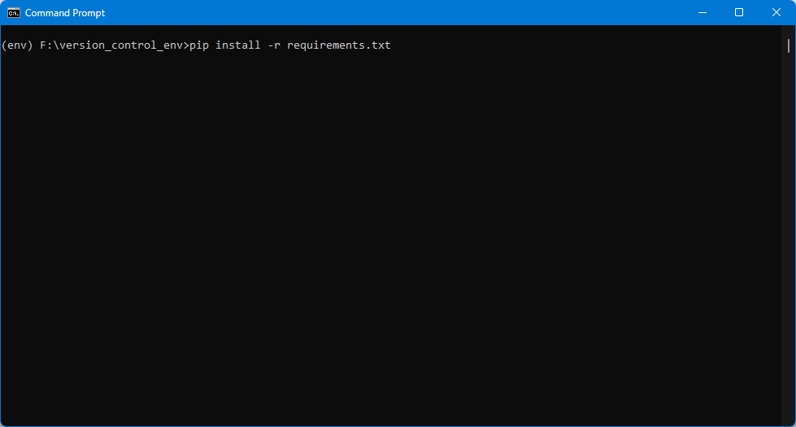

Create a python file

Code:

**new-item test.py**

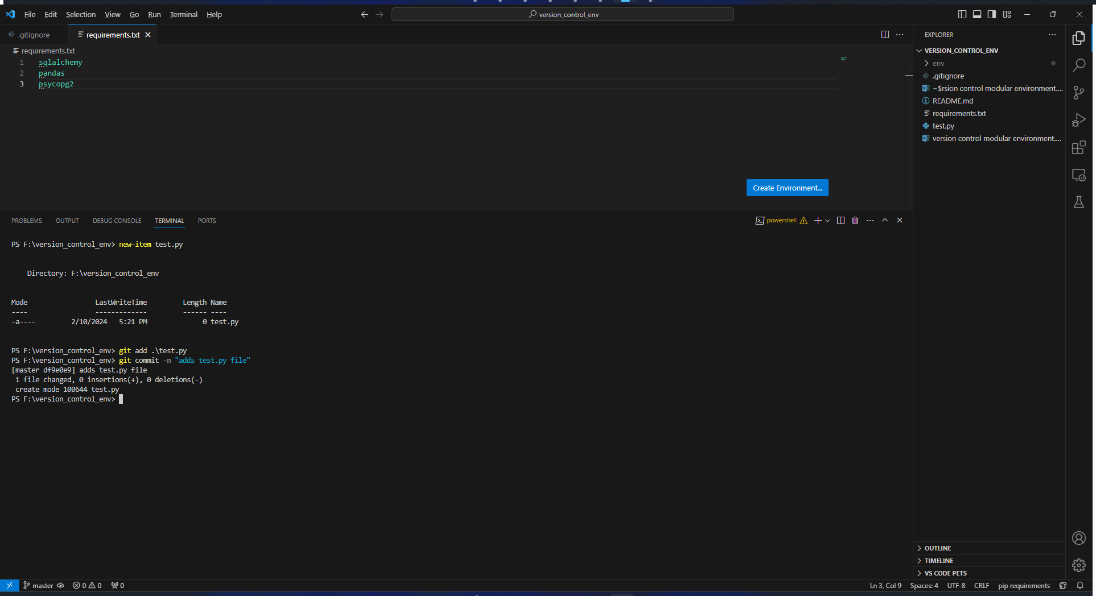

Push local repository files to GitHub cloud

* Add > Add existing repository >

